Ideation Phase
Brainstorm & Idea Prioritization Template

Date | 31 January 2025
Team ID | 6ab3d8050fc666a751b367a2
Project Name | AI StudyBuddy
Maximum Marks | 4 Marks

Brainstorm & Idea Prioritization Template
Brainstorming provides a creative and collaborative environment for developing innovative ideas and solving problems in the AI StudyBuddy project. It encourages users to explore different ideas, share suggestions, and identify useful features for improving the learning and weather information experience.
This template helps organize ideas, prioritize important features, and plan effective solutions for the project. It supports creative thinking and helps shape the project into a useful and user-friendly application.
Step-1: Team Gathering, Collaboration and Problem Statement Selection for AI StudyBuddy

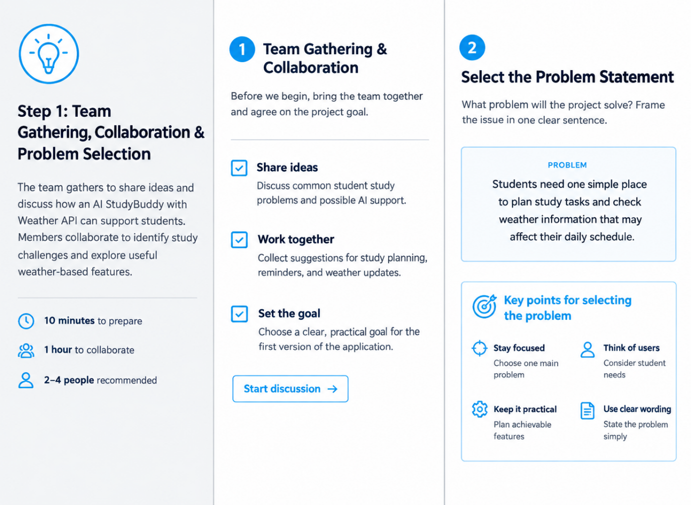

Step-2: Brainstorming, Idea Listing and Grouping for AI StudyBuddy

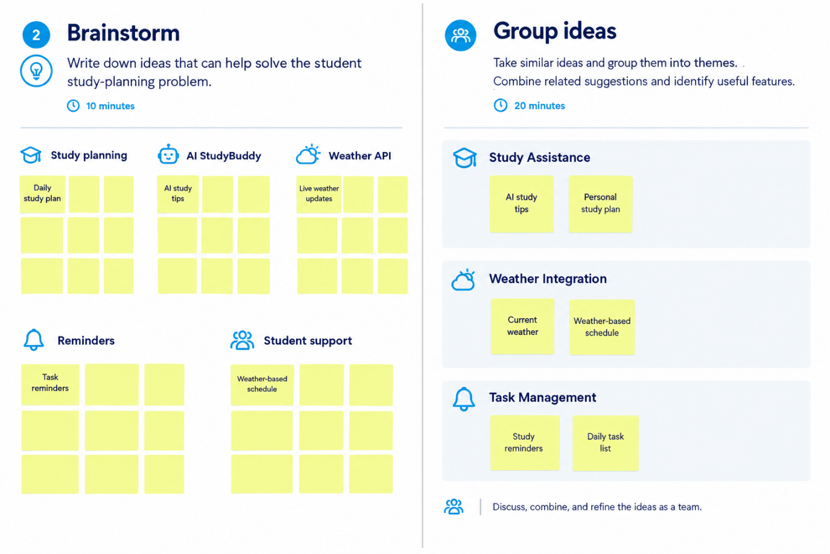

Step-3: Idea Prioritization Based on Importance and Feasibility for AI StudyBuddy with Weather API

